

# Melville Senior High School

### Semester Two Examination, 2020

### Question/Answer booklet

# MATHEMATICS

If required by your examination administrator, please place your student identification label in this box

**METHODS**

**UNITS 1&2**

## Section One:

## Calculator-free

|  |  |  |  |  |  |  |  |  |  |  |
| --- | --- | --- | --- | --- | --- | --- | --- | --- | --- | --- |
| WA student number: In figures |  |  |  |  |  |  |  |  |  |  |

In words

Your name

|  |  |
| --- | --- |
| Number of additional answer booklets used (if applicable): |  |

## Time allowed for this section

Reading time before commencing work: five minutes

Working time: fifty minutes

## Materials required/recommended for this section

***To be provided by the supervisor***

This Question/Answer booklet

Formula sheet

***To be provided by the candidate***

Standard items: pens (blue/black preferred), pencils (including coloured), sharpener,  
correction fluid/tape, eraser, ruler, highlighters

Special items: nil

## Important note to candidates

No other items may be taken into the examination room. It is **your** responsibility to ensure that you do not have any unauthorised material. If you have any unauthorised material with you, hand it to the supervisor **before** reading any further.

## Structure of this paper

|  |  |  |  |  |  |
| --- | --- | --- | --- | --- | --- |
| Section | Number of questions available | Number of questions to be answered | Working time (minutes) | Marks available | Percentage of examination |
| Section One: Calculator-free | 8 | 8 | 50 | 52 | 35 |
| Section Two: Calculator-assumed | 13 | 13 | 100 | 98 | 65 |
|  | | |  | **Total** | 100 |

|  |  |  |
| --- | --- | --- |
| Markers use only | | |
| Question | Maximum | Mark |
| 1 | 6 |  |
| 2 | 7 |  |
| 3 | 6 |  |
| 4 | 6 |  |
| 5 | 7 |  |
| 6 | 7 |  |
| 7 | 6 |  |
| 8 | 7 |  |
| S1 Total | 52 |  |
| S1 Wt (×0.6731) | 35% |  |
| S2 Wt | 65% |  |
| Total | 100% |  |

## Instructions to candidates

1. The rules for the conduct of examinations are detailed in the school handbook. Sitting this examination implies that you agree to abide by these rules.

2. Write your answers in this Question/Answer booklet preferably using a blue/black pen.  
Do not use erasable or gel pens.

3. You must be careful to confine your answers to the specific question asked and to follow any instructions that are specific to a particular question.

4. Show all your working clearly. Your working should be in sufficient detail to allow your answers to be checked readily and for marks to be awarded for reasoning. Incorrect answers given without supporting reasoning cannot be allocated any marks. For any question or part question worth more than two marks, valid working or justification is required to receive full marks. If you repeat any question, ensure that you cancel the answer you do not wish to have marked.

5. It is recommended that you do not use pencil, except in diagrams.

6. Supplementary pages for planning/continuing your answers to questions are provided at the end of this Question/Answer booklet. If you use these pages to continue an answer, indicate at the original answer where the answer is continued, i.e. give the page number.

7. The Formula sheet is not to be handed in with your Question/Answer booklet.

Section One: Calculator-free 35% (52 Marks)

This section has**eight** questions. Answer **all** questions. Write your answers in the spaces provided.

Working time: 50 minutes.

Question 1 (6 marks)

Solve the following equations.

(a) $18x=25x-28$. (1 mark)

(b) ${9x}^{2}=18x$. (2 marks)

(c) $x^{3}-9x^{2}-25x+33=0$. (3 marks)

Question 2 (7 marks)

(a) Simplify $\sqrt{4^{-5}}$. (2 marks)

(b) Write the value of $xy$ in scientific notation when $x=2.5×{10}^{3}$ and $y=5×{10}^{-7}$.

(2 marks)

(c) Determine the value of $n$ given that $9^{n+1}=\sqrt{27}$. (3 marks)

Question 3 (6 marks)

(a) The turning point of a quadratic is at $(-3, -10)$ and the curve passes through $(0, 8)$. Determine the equation of the quadratic in the form $y=ax^{2}+bx+c$. (3 marks)

(b) Functions $f, g$ and $h$ are defined by $f\left(x\right)=3+\sqrt{x-5}, g\left(x\right)=2f(x)$ and $h\left(x\right)=f(x+7)$.

State the

(i) domain of $f(x)$. (1 mark)

(ii) range of $g(x)$. (1 mark)

(iii) domain of $h(x)$. (1 mark)

Question 4 (6 marks)

(a) The point $A(1, 3)$ lies on the curve with equation $y=x^{3}-4x^{2}+7x-1$. Determine the equation of the tangent to the curve at $A$. (3 marks)

(b) Determine $g(1)$ given that $g\left(-1\right)=5$ and $g^{'}\left(x\right)=12x^{3}+4x-3$. (3 marks)

Question 5 (7 marks)

(a) A sequence is defined by $T_{n+1}=T_{n}+0.3, T_{1}=5$. Determine

(i) $T_{101}$. (2 marks)

(ii) the sum of the first $101$ terms of the sequence. (2 marks)

(b) The sum to infinity of the series $4+4k+4k^{2}+4k^{3}+…$ is $10$. Determine the sum of the first three terms of the series. (3 marks)

Question 6 (7 marks)

(a) Part of the graph of $y=a\cos\left(x-θ\right)$ is shown below.

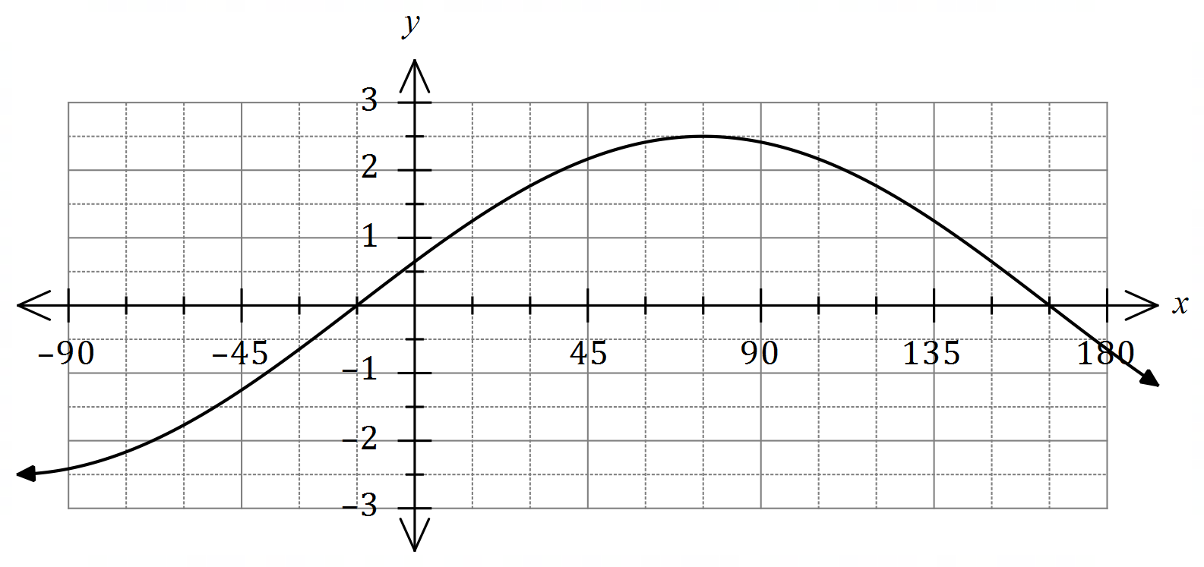

State the value of the constant $a$ and the value of the constant $θ$, $0°≤θ≤180°$.

(2 marks)

(b) Show that $\cos{(x+y)}+\cos{(x-y)}=k\cos{x}\cos{y}$ and state the value of the constant $k$.

(2 marks)

(c) Determine an exact value for $\cos{75°}+\cos{15°}$. (3 marks)

Question 7 (6 marks)

Consider the function defined by $f\left(x\right)=2x^{2}+5$.

(a) Determine $f'(-3)$. (1 mark)

(b) Show that when $x=3$, the expression $f\left(x+h\right)-f(x)$ simplifies to $12h+2h^{2}$. (3 marks)

(c) Show use of the result in (b) and the formula $f^{'}\left(x\right)=\lim_{h→0}{\begin{matrix}f\left(x+h\right)-f(x) \\ \overline{ h }\end{matrix}}$ to determine the value of $f'(3)$. (2 marks)

Question 8 (7 marks)

The line $y=3x+c$ is a tangent to the curve $y=x^{3}-3x^{2}-6x+7$. Determine the value(s) of the constant $c$.

Supplementary page

Question number: _________

© 2020 WA Exam Papers. Melville Senior High School has a non-exclusive licence to copy and communicate this document for non-commercial, educational use within the school. No other copying, communication or use is permitted without the express written permission of WA Exam Papers. SN063-162-1.